Abstract format – place your title here formatted as shown here in bold: use Times New Roman font and do not capitalise first letters or whole title
Author 1¹, Author 2¹, Author 3²
¹ Affiliation 1 ² Affiliation 2

INTRODUCTION: For the abstract, adhere to the provided style. The required styles illustrated in this Microsoft WORD document, must be used as a template for production of abstracts, by replacing the relevant text with your own, by cutting and pasting of unformatted text to maintain the present format. IMPORTANT: DO NOT INTERFERE WITH HEADER OR FOOTER.
METHODS: All abstracts are to be formatted to a single A4 page (210 x 297 mm). The top margin should be set to 15 mm, bottom margin to 25 mm, and 1eft and right margins to 20 mm. The entire document is set to 2 columns with 10 mm of intercolumn spacing (giving a column width of 80 mm). The body of the document should be set in 11 pt Times New Roman, justified, with single line-spacing. Do not use fonts other than Times New Roman or Symbol in the document (including equations and figures).
Title should be in bold, styled as shown. Authors should be listed consecutively (as above) by initials and last name, punctuated as shown. Authors may be hyperlinked to the e-mail address (as shown above). Affiliation should be indicated with superscripted suffix Arabic numerals. Do not append degrees, professional designations, etc., to names. Affiliations should be listed consecutively and may be hyperlinked to a web page (as examples above). Sample reference entries [l-3] are given in the References section. References, if included, should be set as one block, as below, and a maximum of four references may be used.
RESULTS: Figures should use Figure style and have the caption below them. Tables should use Table style and have the caption above them. Figure and table caption styles are FigCaption and TableCaption, respectively. Scanned figures should have a minimum resolution of 200 dpi for an 80 mm figure width. Inclusion of figures and/or tables is optional.
Equations should use Equation style:
k(t) = μ exp(-μ t/η) 1(t) (1)
and should be tab centred, with the number in parentheses on the right.
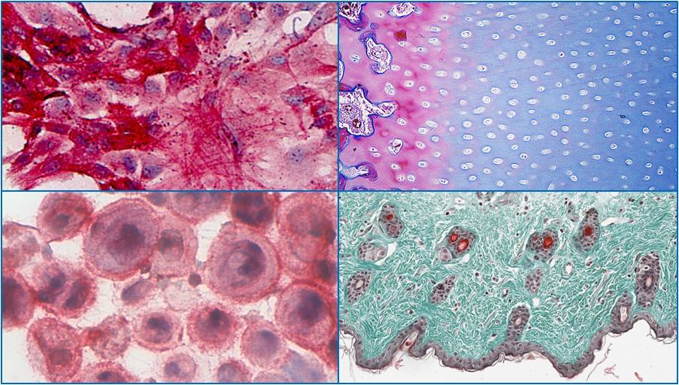
Fig. 1: Images should be compressed to 200dpi for printing, before saving. Include Scale Line value (micrographs) if not already embedded in the image.
Table 1. Title here.
 | Amount of Resources | Allocation Freedom
Industry | high | constrained
Academic | Low | unconstrained

DISCUSSION & CONCLUSIONS: Abstracts must not exceed one page. Do NOT tamper with the header or footer. Convert abstract to pdf file and name your file as described below and upload via the website. If this does not work email to the NVMB secretary. Word files will not be accepted.
REFERENCES: not essential but if included use this format ¹ M. Ziegler (1991) Essentials of Writing Biomedical Research Papers, McGraw-Hill, Inc. ² I.R. Spears, M. Pfleiderer, E. Schneider, et al (2000) J Biomech 33:1471-77. ³ A.R Poole, M. Alini, and A Hollander (1995) Chondrocytes and cartilage destruction in Mechanisms and Models in Rheumatoid Arthritis (eds B. Henderson, J. Edwards, and R. Pettipher) Academic Press, pp 163-204.
ACKNOWLEDGEMENTS: Put here if any.

Your file should be named as indicated when saving and submitting so we can track abstracts to individual authors
Filename: SurnameNVMB2025 – if necessary, add a number suffix if you are submitting more than 1 abstract.

